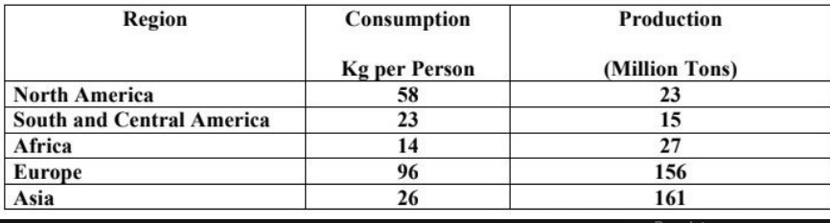



**Tham khảo cách làm dạng table** [**https://www.ieltstutor.me/blog/table**](https://www.ieltstutor.me/blog/table)

Given is the table comparing various areas in terms of their figures for consumption and production of potato in 2006. In general, Europe and Asia were the two main sources of potatoes in the world, whereas people in North America tended to consume potatoes the most.

In 2006, the figure for potato production in Asia stood at 161 million tons, compared to only 156 million tons in Europe. Meanwhile, each European ate around 96 kilograms of potatoes, which outnumbered the data of Asians by a wide margin of 70 kilograms.

Furthermore, North America produced 23 million tonnes of potatoes, which was nearly double the data in South and Central America. Additionally, the figures for potato consumption in North America along with South and Central America were 58 and 23 kilograms per person respectively. Finally, the data on the production and consumption of potatoes in Africa stood at 27 million tonnes and 14 kilograms each person correspondingly. **→ Nội dung bài thì thực ra mình có thể triển khai “production" riêng và “consumption" riêng mỗi cái 1 thân bài nè.**

**Vì triển khai chia cặp cũng không có nhiều giá trị liên quan đến nhau lắm.**

[**IELTS TUTOR**](https://www.ieltstutor.me/blog/sua-de-thi-ielts-writing-22-8-2020) **lưu ý:**

* Dạng biểu đồ này thì đã rất quen thuộc với các bạn học sinh [lớp IELTS ONLINE WRITING 1 KÈM 1 của IELTS TUTOR](https://www.ieltstutor.me/intensive-writing) rồi nhé.
* Overall:
  + Asia and Europe were two primary potato producing regions, whereas Europe and North America were the two largest consumers. >> IELTS TUTOR gợi ý [Phân biệt However/ Whereas](https://www.ieltstutor.me/blog/phan-biet-however-whereas)
* Body 1: Viết về biểu đồ 1: Looking at the regional [consumption](https://www.ieltsdanang.vn/blog/cach-dung-danh-tu-consumption)
  + Europe was the biggest consumer with 96.1 kg potatoes eaten [per](https://www.ieltstutor.me/blog/cach-dung-tu-per-tieng-anh) person.
  + It was followed by North America where per capita potato [usage](https://www.ieltsdanang.vn/blog/cach-dung-danh-tu-usage-tieng-anh) was comparatively less, at only 57.9 kg.
  + At the next levels were Asia and South and Central America. These areas had similar levels of consumption, at 25.8 and 23.6 kg respectively. >> IELTS TUTOR hướng dẫn [Cách dùng danh từ "level" tiếng anh](https://www.ieltsdanang.vn/blog/cach-dung-danh-tu-level-tieng-anh#:~:text=education%20level%20(IELTS%20TUTOR%20gi%E1%BA%A3i,c%C3%B3%20tr%C3%ACnh%20%C4%91%E1%BB%99%20nh%C6%B0%20nhau))
  + An [average](https://www.ieltsdanang.vn/blog/cach-dung-average-tieng-anh#:~:text=IELTS%20TUTOR%20x%C3%A9t%20v%C3%AD%20d%E1%BB%A5,th%C3%ADch%3A%20l%E1%BA%A5y%20s%E1%BB%91%20trung%20b%C3%ACnh)) person in Africa ate less than half this amount (14.1 kg) annually, making it the smallest consumer.
* Body 2: Viết về biểu đồ 2: As regards the production,
  + Asia and Europe were the two largest potato producers in 2006, with their production amounting to approximately 131 and 126 million tonnes [respectively](https://www.ieltsdanang.vn/blog/paraphrase-respectively-ielts-writing-task-1).
  + North America stood at the third position, but its contribution was only 24.7 million tonnes which is about one fifth of the European share. >> IELTS TUTOR hướng dẫn [Cách dùng danh từ "contribution" tiếng anh](https://www.ieltsdanang.vn/blog/cach-dung-danh-tu-contribution-tieng-anh)
  + The other regions, South and Central America and Africa, were far behind Europe when each of them produced around 16 million tonnes of potatoes, [nearly](https://www.ieltsdanang.vn/blog/phan-biet-almost-nearly-tieng-anh) one eighth the European proportion.